Personal Development Report

Hristo Hristov

Contents

Introduction 1

Learning Outcomes 1

1. Data preparation 1

2. Data analysis & model engineering 2

3. Reliability and transparency 2

4. Targeted interaction 3

5. Future orientation 3

6. Investigative problem solving 3

7. Personal leadership 3

# Introduction

This document is written with the purpose of documenting my personal development through the semester 4 of AI42.

# Learning Outcomes

## Data preparation

* 1. Definition

You are able to prepare and store a given dataset in such a way that it can be used in your data analysis and/or modelling.

Clarification:

Preparing a dataset consists of extending it with additional data and cleaning the data according to theories of data quality, in such a way that the process of cleaning and preparing those data is repeatable, transparent to others, and the results are suitable for data analysis and/or modelling. Storing a dataset includes investigating cloud solutions and arguing whether they should be used.

* 1. Self-evaluation

| Advanced | Proficient | Beginning | Orienting | Undefined | **Total points** |
| --- | --- | --- | --- | --- | --- |
| 4 Points | 3 Points | 2 Points | 1 Points | 0 Points | 4 Points |

I believe I am at the orienting level because I have gotten familiar with the 5 different data quality measures: Validity, Accuracy, Completeness, Consistency and Uniformity. I have also started diving into the different techniques used for data cleaning (such as dropping data, filling in missing data, hot-shot encoding). I also have done a research exercise in regards to data cleaning

* 1. Proof

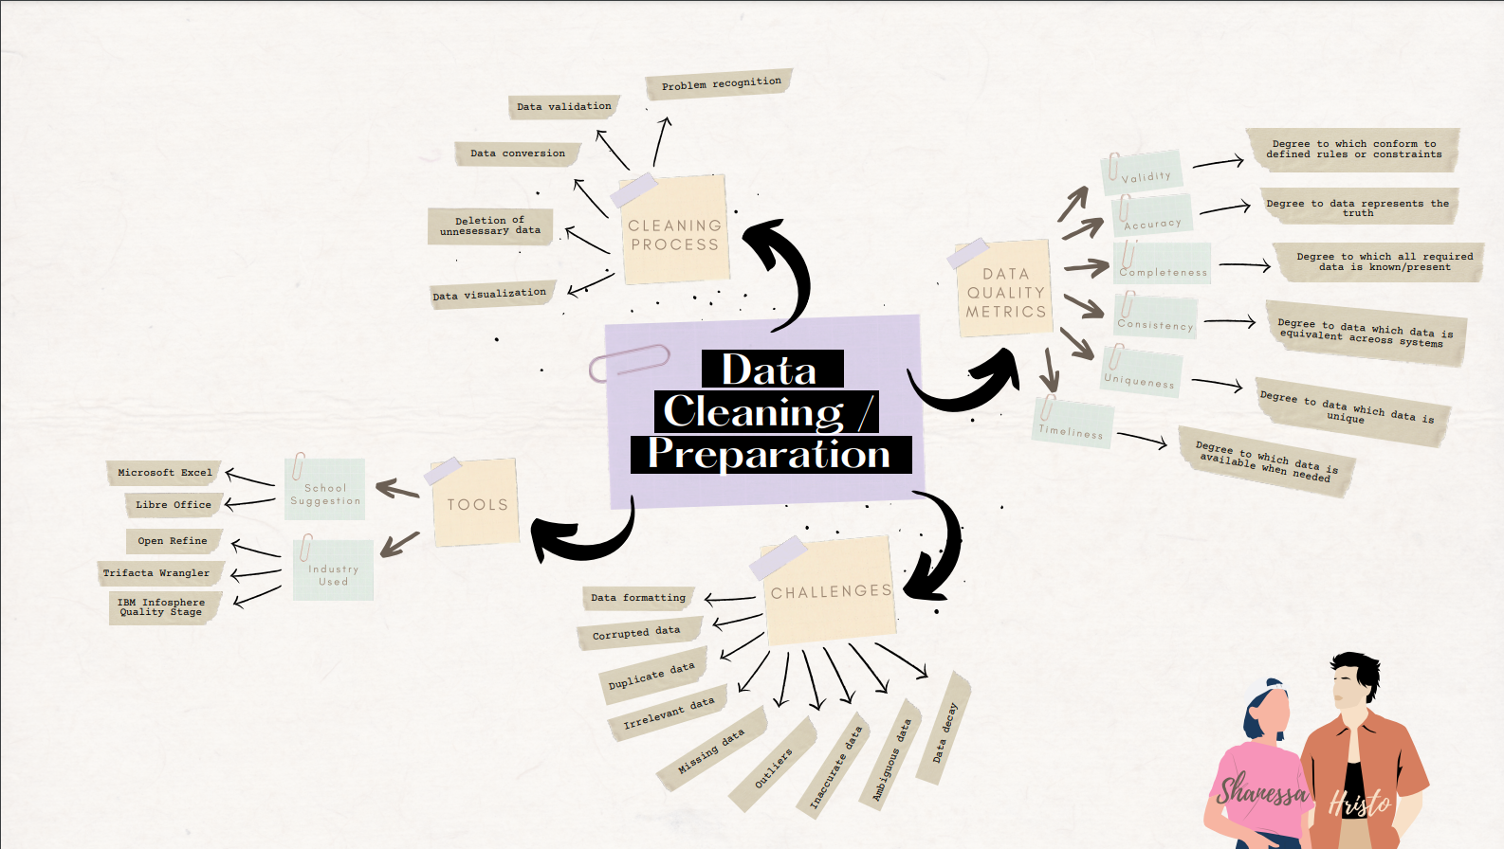

## Data analysis & model engineering

* 1. Definition

You are able to apply machine learning algorithms and other data analysis techniques to a prepared dataset.

Clarification

Applying consists of training of different types of models (classification, regression, etc.), and evaluating the results with respect to recall, precision, accuracy, cross-validation, etc. as well as tuning hyper-parameters. Other data analysis techniques are for example: descriptive statistics, derived columns, forecasting, trend analysis, clustering, etc.

* 1. Self-evaluation

| Advanced | Proficient | Beginning | Orienting | Undefined | **Total points** |
| --- | --- | --- | --- | --- | --- |
| 4 Points | 3 Points | 2 Points | 1 Points | 0 Points | 4 Points |

I believe I am at orienting level because I have started applying different algorithms (2 classification and 1 regression algorithm) to my data. I have also tuned different hyper-parameters such as KNeighborsClassifier for nearest neighbors and n-estimators for decision trees

* 1. Proof

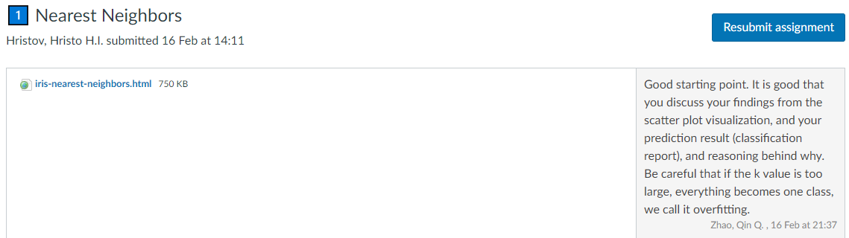

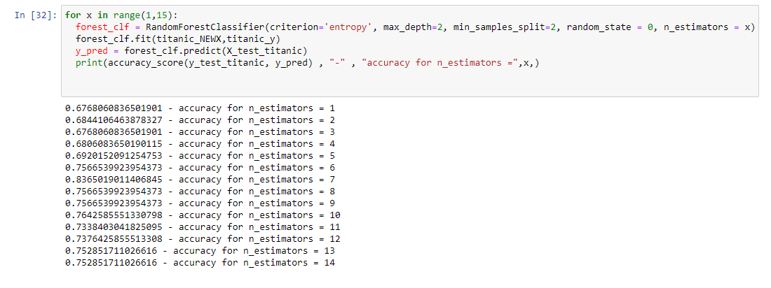

## Reliability and transparency

* 1. Definition

You are able to address reliability and transparency aspects during data analysis and/or modelling.

Clarification

Reliable means that conclusions are supported by methodologically acquired and evaluated results, recommendations make sense in regards to the domain knowledge, and used sources are referenced appropriately. Transparent refers to the process being clear to such a degree that it is reproducible, results being explainable to humans and based on decision making that is considered fair, whilst eliminating bias.

* 1. Self-evaluation

| Advanced | Proficient | Beginning | Orienting | Undefined | **Total points** |
| --- | --- | --- | --- | --- | --- |
| 4 Points | 3 Points | 2 Points | 1 Points | 0 Points | 4 Points |

sadas

* 1. Proof

## Targeted interaction

* 1. Definition

You use appropriate communication to address your audience considering your role, your audience and the medium to convey your message regarding the approach and results of your data analysis and/or modelling.

Clarification

Appropriate communication means reporting and/or presenting the approach, process or outcomes of a data analysis in a methodologically sound way. You can reflect on the effect of your communication and based on that reflection you define steppingstones ahead on the task, on the role and on the projected results. Interaction about data analysis is based on a systematic approach (such as the IBM Data Science Methodology) and comprises 4 phases/components: 1) project proposal 2) data preparation 3) data analysis/modelling 4) results and evaluation.

Based on your message, your position and the person(s) you address, you choose the right channel and format to communicate results, including appropriate data visualizations (such as data stories, infographics, or (a set of) static or interactive plot(s)).

* 1. Self-evaluation

| Advanced | Proficient | Beginning | Orienting | Undefined | **Total points** |
| --- | --- | --- | --- | --- | --- |
| 4 Points | 3 Points | 2 Points | 1 Points | 0 Points | 4 Points |

* 1. Proof

## Future orientation

* 1. Definition

You are able to assess the context of data analysis and/or modelling from multiple perspectives in order to pursue this project in a sustainable manner.

Clarification

Assess the context means the organizational and societal environment in which the data analysis project takes place. You show that you can identify the hallmarks and roles of the environment of the assignment and have a keen eye for a future-oriented, sustainable embedding of your work in an organization and society. Multiple perspectives include social and ethical considerations, law compliance, organizational data maturity, alignment with sustainable development goals, recognizing own boundaries and those of others and acting accordingly. Reflecting on ethics and governance of AI-based automated decision-making will be an important and integral part of your learning process.

* 1. Self-evaluation

| Advanced | Proficient | Beginning | Orienting | Undefined | **Total points** |
| --- | --- | --- | --- | --- | --- |
| 4 Points | 3 Points | 2 Points | 1 Points | 0 Points | 4 Points |

dsa

* 1. Proof

## Investigative problem solving

* 1. Definition

You are able to critically consider a data analysis and/or modelling project from various perspectives, identifying problems, finding an effective approach and coming up with appropriate solutions.

Clarification

Identifying the problem means you can formulate a clear hypothesis and research question in order to determine the aim of solution using an inquiring mindset. Effective approach means you compose and pursue applied research methods (such as the DOT framework) and approaches based on reliable and verifiable sources. You are able to methodically and creatively find answers to applied research questions, considering alternatives and critically analyzing your own and others’ line of reasoning.

* 1. Self-evaluation

| Advanced | Proficient | Beginning | Orienting | Undefined | **Total points** |
| --- | --- | --- | --- | --- | --- |
| 4 Points | 3 Points | 2 Points | 1 Points | 0 Points | 4 Points |

* 1. Proof

## Personal leadership

* 1. Definition

You show an entrepreneurial mindset regarding the data analysis and/or modelling project and your personal development, while being aware of your own learning capacity and keeping in mind your professional ambitions in the field of Artificial Intelligence.

Clarification

Entrepreneurial mindset includes being aware, seeing opportunities and seizing them, motivating oneself and others, being able to profile oneself, a team and others. Learning capacity means guiding your own development and study progress, showing leadership and taking responsibility, enhancing ones' own learning capacity, demanding and giving active feedback, all with respect to the learning outcomes. Professional ambitions means you are examining what type of professional you want to be in the long term, which field and type of position you aspire to and how you can stand out from others in field of AI/data.

* 1. Self-evaluation

| Advanced | Proficient | Beginning | Orienting | Undefined | **Total points** |
| --- | --- | --- | --- | --- | --- |
| 4 Points | 3 Points | 2 Points | 1 Points | 0 Points | 4 Points |

In regards to this learning outcome I believe I am still simply in the orienting phase. I come to this conclusion based not only in my development on my personal challenge and exercises but also based on the group project. While I am still in the beginning of my individual challenge and I am struggling of choosing a direction/topic out of all the possibilities, I am also orienting myself in the group project with regards to other people. Evaluating who is good at which task and how I can suggest to divide the work in such a way that everybody is doing their best.

* 1. Proof